**Python Assignment**

**30th Jan. 2023**

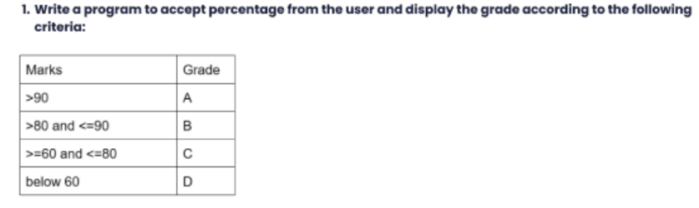

**Sol.**

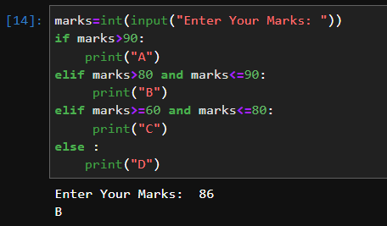

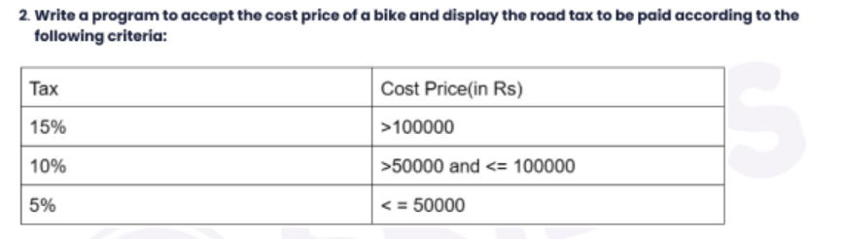

**Sol.**

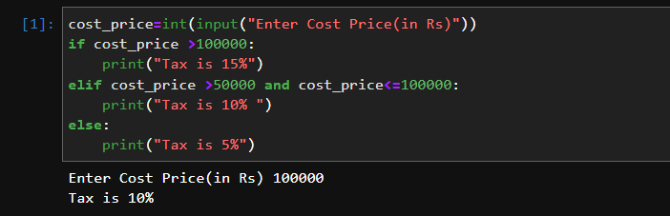

**Q5 Why and When to use while loop in Python give a detailed description with example?**

**Sol.** Python while loop is used to run a block code until a certain condition is met.

The Syntax of While loop is :

While Condition:

#body of while loop

Here,

1. A while loop evaluates the condition
2. If the condition evaluates to True, the code inside the while loop is executed.
3. condition is evaluated again.
4. This process continues until the condition is False.
5. When condition evaluates to False, the loop stops.

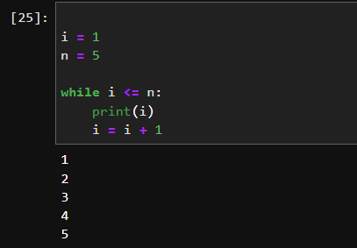

**Q6 Use nested while loop to print 3 different pattern?**

**Sol.**

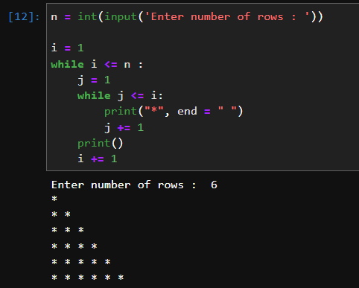

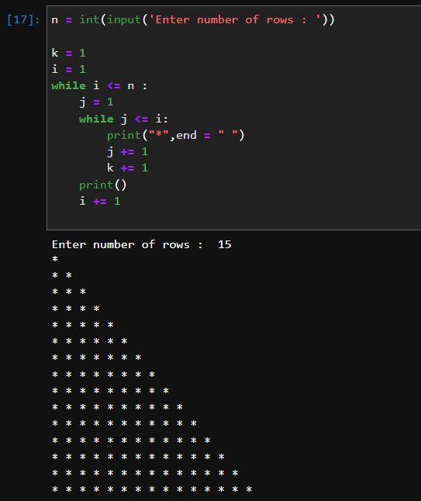

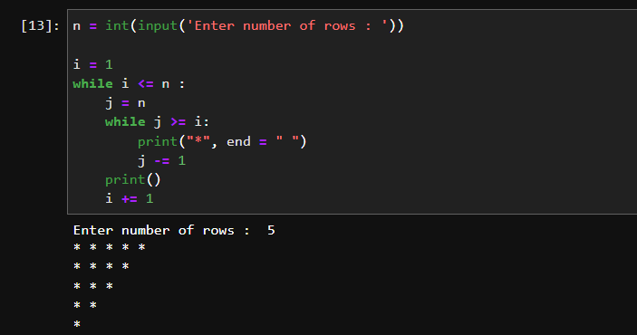

**Q7 Reverse a While loop to display number from 10 to 1 ?**

**Sol.**

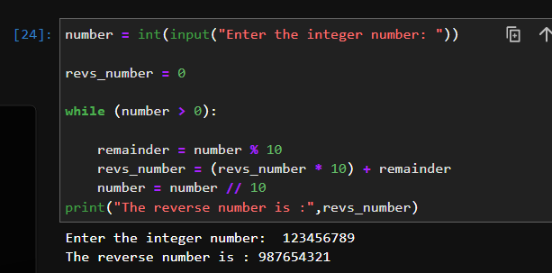  
**Q8 Reverse a While loop to display number from 10 to 1 ?**

**Sol**.



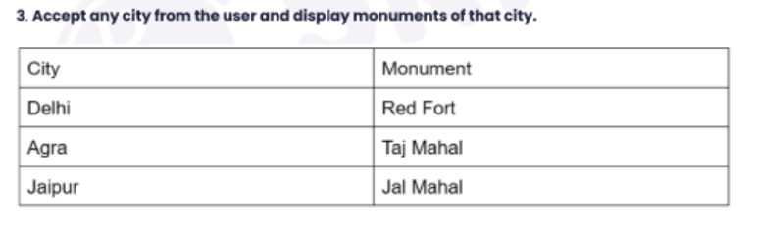

**Sol.**

